EXPERIMENT NO. 30

Collaborating on a GitHub Project Using Fork, Branches, and Pull Requests

Aim
To collaborate on a GitHub project by forking a repository, cloning it locally, creating a new branch, implementing a feature, pushing the changes, and submitting a Pull Request to the original repository.

Software Requirements
- Windows 10/11 (or Linux/macOS)
- Git
- GitHub Account
- Visual Studio Code (or any code editor)
- Web Browser
- Internet Connection

Theory
The Fork and Pull Request workflow is widely used in collaborative and open-source software development. A developer first forks the original repository to create a personal copy, clones it to the local machine, creates a separate branch for a new feature, and makes the required changes. After committing and pushing the changes to the forked repository, a Pull Request is created to request that the original repository owner review and merge the changes.

Procedure
Step 1: Fork the Repository
- Open GitHub.
- Select the original repository.
- Click the Fork button.
- Wait for GitHub to create a copy under your account.
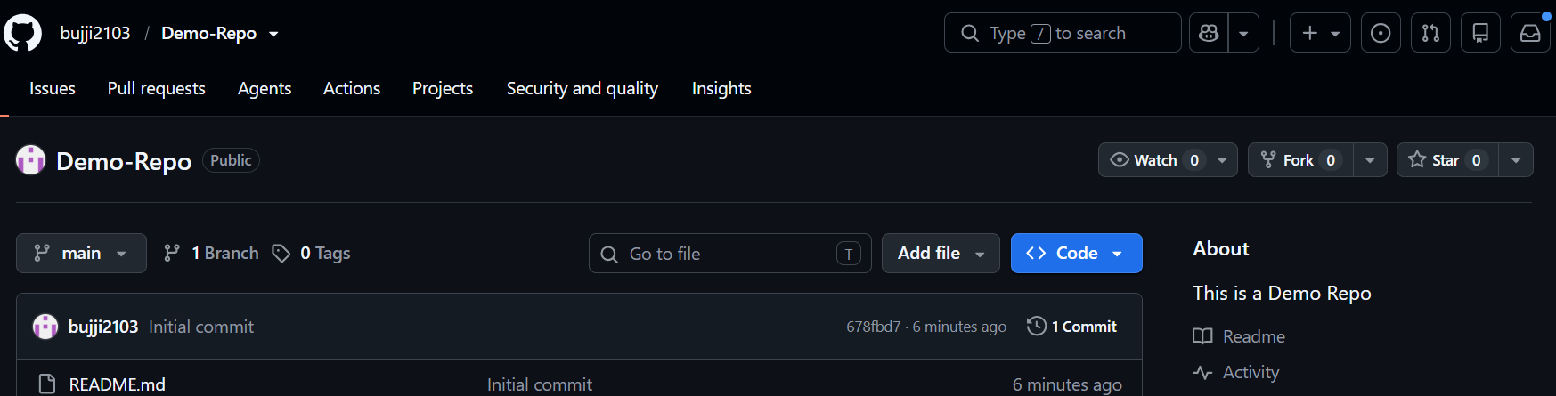

Step 2: Clone the Forked Repository
Open Git Bash or Terminal.
git clone https://github.com/YourUsername/RepositoryName.git

Navigate to the project folder.
cd RepositoryName
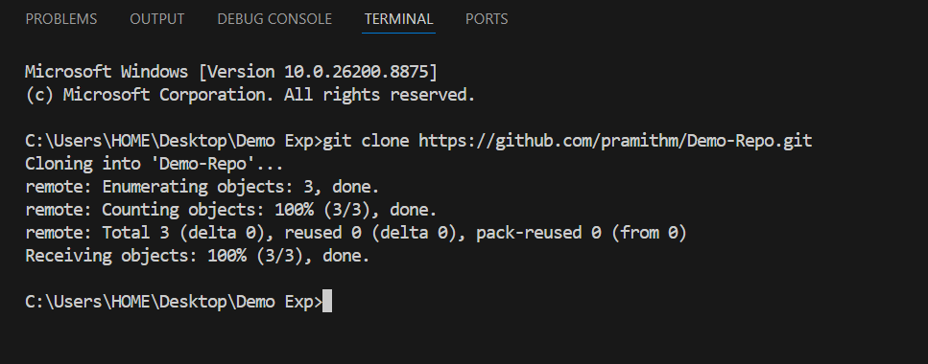

Step 3: Fetch the Latest Changes
Add the original repository as the upstream remote.
git remote add upstream https://github.com/OriginalOwner/RepositoryName.git

Fetch the latest changes.
git fetch upstream

Update the local main branch.
git checkout main
git merge upstream/main

Step 4: Create a New Feature Branch
Create and switch to a new branch.
git checkout -b feature-update

Verify the branch.
git branch
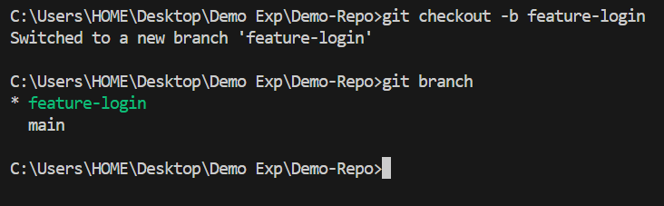

Step 5: Implement the Feature
- Open the project in Visual Studio Code.
- Add a new feature or modify an existing file.
- Save the changes.
Step 6: Stage and Commit the Changes
Check the repository status.
git status

Stage the changes.
git add .

Commit the changes.
git commit -m "Added new feature"

Step 7: Push the Feature Branch
git push origin feature-update

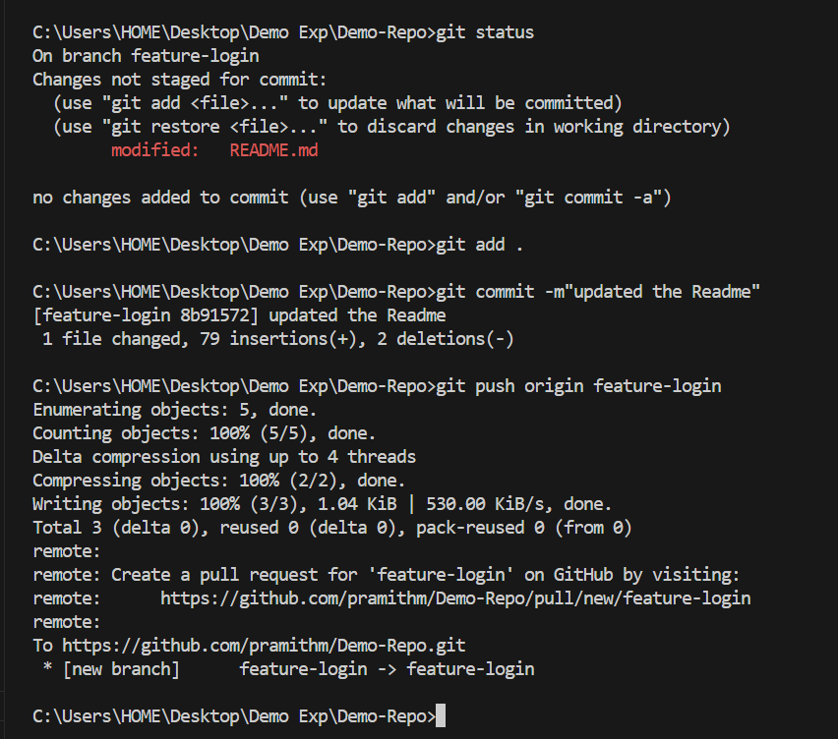

Step 8: Create a Pull Request
- Open your forked repository on GitHub.
- Click Compare & Pull Request.
- Ensure Base repository: Original repository, Base branch: main, Head repository: Your fork, Compare branch: feature-update.
- Enter a title and description.
- Click Create Pull Request.
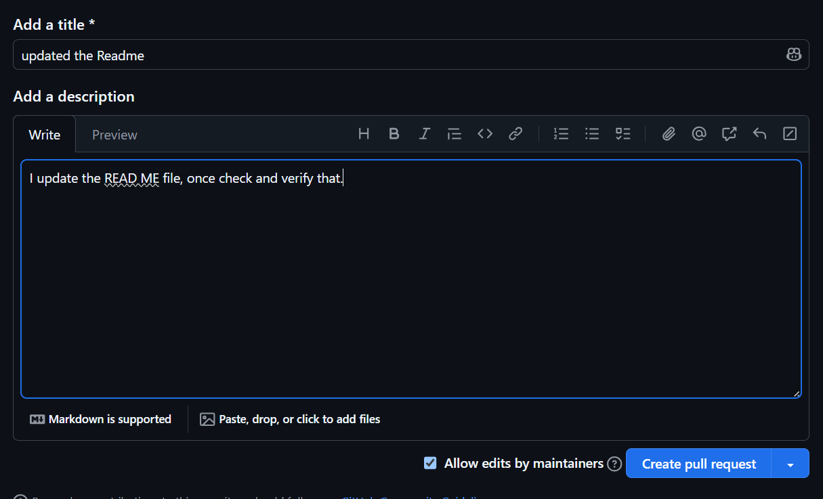
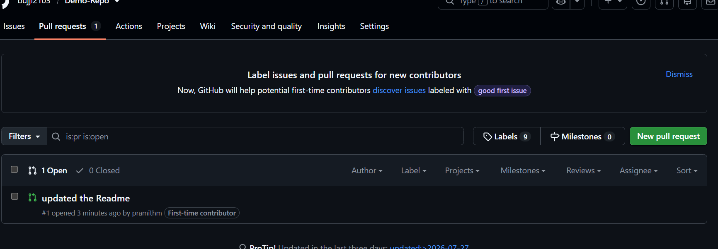

Screenshots
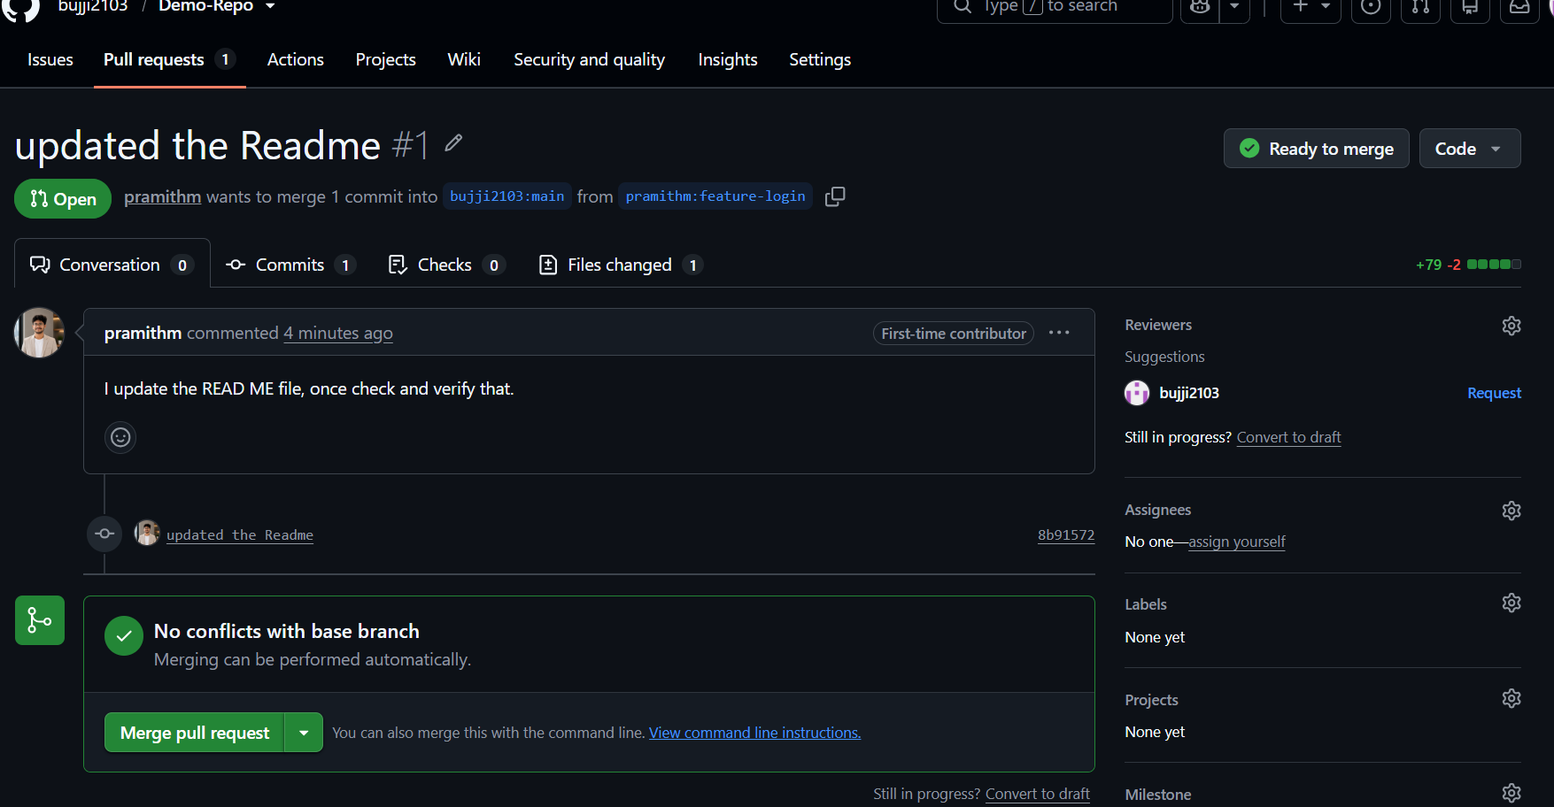

Observation
- The repository was forked successfully.
- The forked repository was cloned to the local machine.
- The latest changes were fetched from the original repository.
- A new feature branch was created.
- The feature was implemented and committed successfully.
- The branch was pushed to the forked repository.
- A Pull Request was submitted to the original repository.

Result
The collaborative GitHub workflow was successfully completed by forking the repository, fetching the latest updates, creating a feature branch, implementing the required changes, pushing them to the forked repository, and submitting a Pull Request to the original repository for review and merging.

